Below is a GOLD-STANDARD, repeatable navigation & workflow for Step 2 — Learn a tiny concept (5–20 min), using 👉 the concept: variable.
This is written so you can run it exactly the same way for ANY future concept (loops, lists, functions, etc.).

🧭 STEP 2 — LEARN A TINY CONCEPT (5–20 MIN)
Goal of Step 2:
Build a clear mental model of ONE idea — before heavy coding.
You should finish this step able to explain the concept out loud in plain English.

⏱️ Time Box (STRICT)
- Minimum: 5 minutes
- Maximum: 20 minutes
⛔ If you exceed 20 minutes → you are over-studying.

🧩 Focus Concept Example: VARIABLE
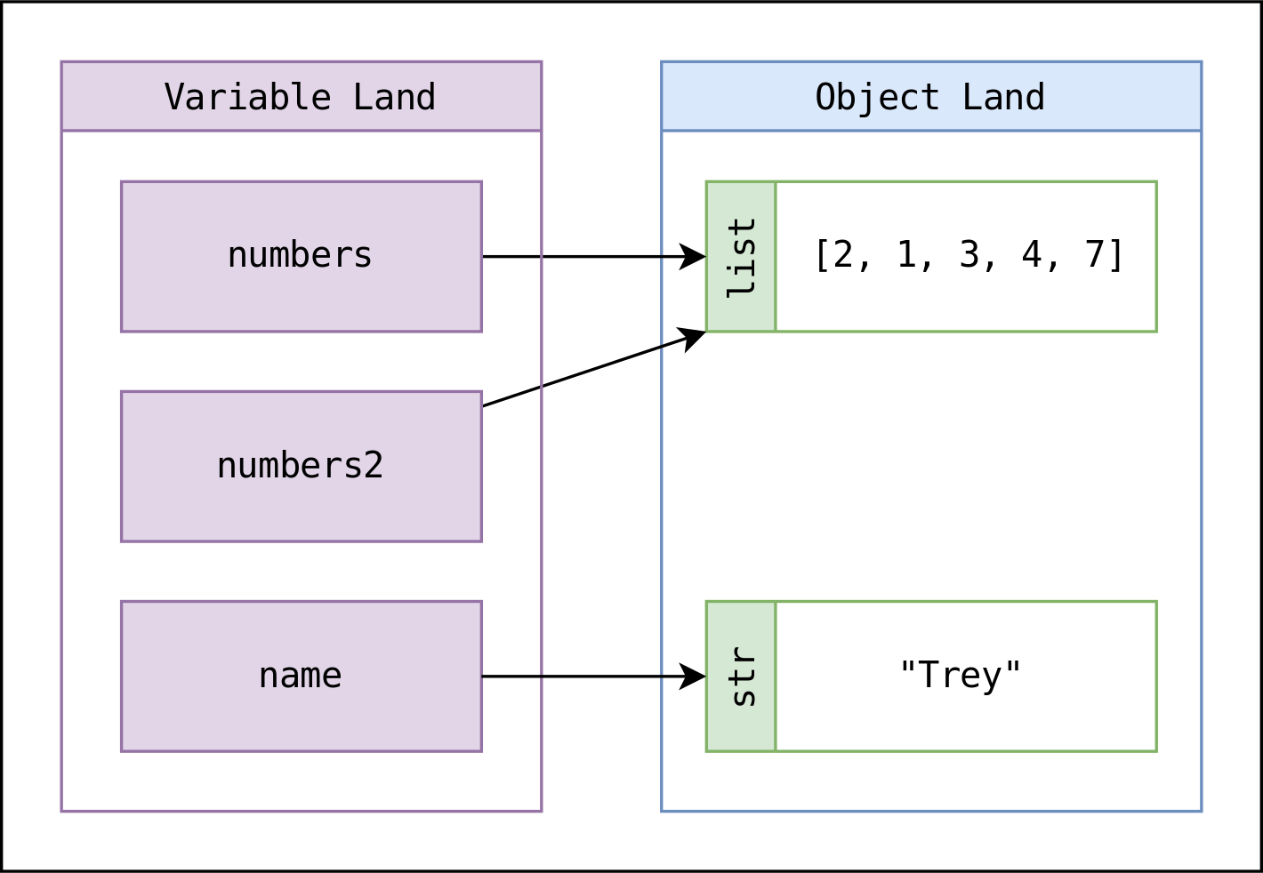
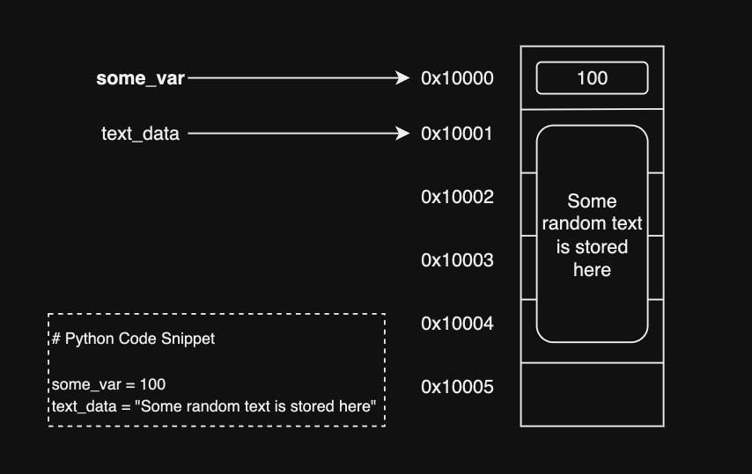
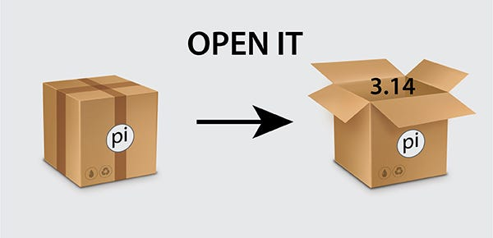

🔢 SUB-STEPS (DO THESE IN ORDER)

2.1 Define the Concept (1–2 min)
Action
- Write a one-sentence definition in your notebook (Markdown cell).
For “variable”
A variable is a name that refers to a value stored in memory.
Rules
- No jargon beyond what you already know
- One sentence only
- If you can’t keep it simple → you don’t understand it yet
✅ Checkpoint:
You can say this sentence out loud without hesitation.

2.2 Answer the “WHY” Question (2–3 min)
Action
- Write why this concept exists.
- Use bullet points, not paragraphs.
For “variable”
Why variables exist:
- To store data
- To reuse values
- To give meaning to numbers and text
- To avoid repeating calculations
Mental rule
If you don’t know why it exists, you won’t know when to use it.
✅ Checkpoint:
You could explain to a non-programmer why variables matter.

2.3 Build the Mental Model (3–5 min)
Action
- Use an analogy.
- Write it as a short explanation.
For “variable”
Mental model:
A variable is like a label stuck onto a box.
The box holds the value.
The label (name) lets you find the value again.
Important
- Do NOT mention Python syntax yet
- This is about how your brain pictures it
✅ Checkpoint:
You can draw this on paper in under 10 seconds.

2.4 Identify the Core Operations (3–4 min)
Action
List what you can do with this concept.
For “variable”
What you can do with variables:
- Create them
- Read their value
- Change their value
- Use them in expressions
Rule
- No examples yet
- Just capabilities
✅ Checkpoint:
You can predict what actions might be possible before coding.

2.5 See the Simplest Possible Example (2–4 min)
Action
- Look at ONE minimal example
- Do NOT run it yet
- Just read and interpret
For “variable”
age = 10
Ask yourself (write answers):
- What is the variable name? → age
- What is the value? → 10
- What changed in memory? → a name now refers to 10
⛔ No experimenting yet
⛔ No adding lines
✅ Checkpoint:
You can explain what happens without touching the keyboard.

2.6 Identify Common Confusions (2–3 min)
Action
Write 2–3 things beginners often misunderstand.
For “variable”
Common confusions:
- Thinking the variable *is* the value
- Thinking the name stores data physically
- Confusing = with “equals” instead of “assigns”
Why this matters
This primes your brain to notice mistakes early.
✅ Checkpoint:
You can spot these errors when they appear later.

2.7 Decide You Are “Ready to Code” (Final Check)
Before moving to Step 3, confirm:
✅ I can define the concept in one sentence
✅ I know why it exists
✅ I have a mental picture
✅ I know what actions are possible
✅ I can explain a basic example without running it
If any box is unchecked → repeat Step 2 briefly.

🏁 OUTPUT OF STEP 2 (MANDATORY)
At the end of Step 2, your notebook contains:
- A one-sentence definition
- A “why it exists” list
- A mental model explanation
- A list of core operations
- One minimal example (not executed)
- Common confusions
This becomes your reference when debugging later.

🔑 BIG TAKEAWAY (REMEMBER THIS)
Step 2 is about THINKING, not typing.
If you rush this step, every later step becomes slower and more painful.
When you’re ready, we move cleanly into:
➡️ Step 3 — Attempt code (micro-test cells)
(where mistakes are expected and welcomed)
Say the word when you want that walkthrough next.

